**FILE LINKS**

**SOFT LINKS:**

What is Soft link?

* A symbolic link, also known as symlink or soft link, is a special type of file that points to source file or directory in Linux.
* It is like a shortcut in Windows which contains the path of the original file and not the contents.

Syntax:

* ln -s <Source File> <Destination File>

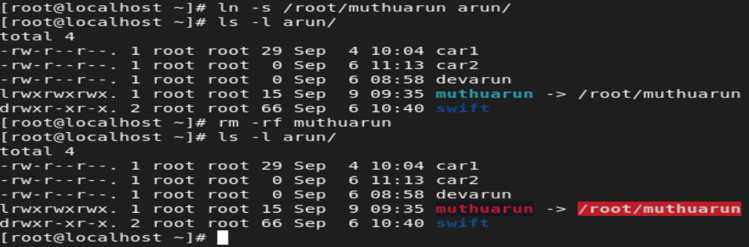

* Soft link is similar to the file shortcut in Windows.
* Changes in both the files will reflect simultaneously
* Soft links can be created on different file systems
* Soft link can be created to files and directories
* It has different inode number and file permissions compared to the original file.
* When the original file is removed, the link will be inaccessible because it points to a non-existent file. This is called the hanging link.

**HARD LINKS:**

What is Hard Link?

* Hard link is a mirror copy of the original file.
* Deleting the original file will not impact anything, because the hard link file, will act as a mirror copy of the original file.

Syntax:

* ln <Source file> <Destination file>

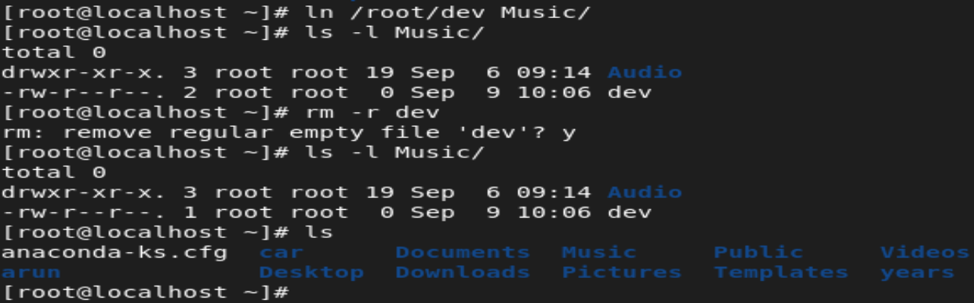

* Hard link is a mirror copy of the original file.
* It is like a soft link.
* Hard link can only be created on the same file system.
* Only files can be linked
* It has the same inode number and file permissions.
* Nothing happens when the original file is removed.

**INODE NUMBER:**

What is inode number?

* An inode is a data structure that is used to store information of files on your Linux system.
* The number of inodes shows the number of files and directories you have on the system
* Every inode in the Linux structure has a unique number identified with it.
* It is also called the index number

Syntax:

* ls -li 🡪 i denotes for inode number.

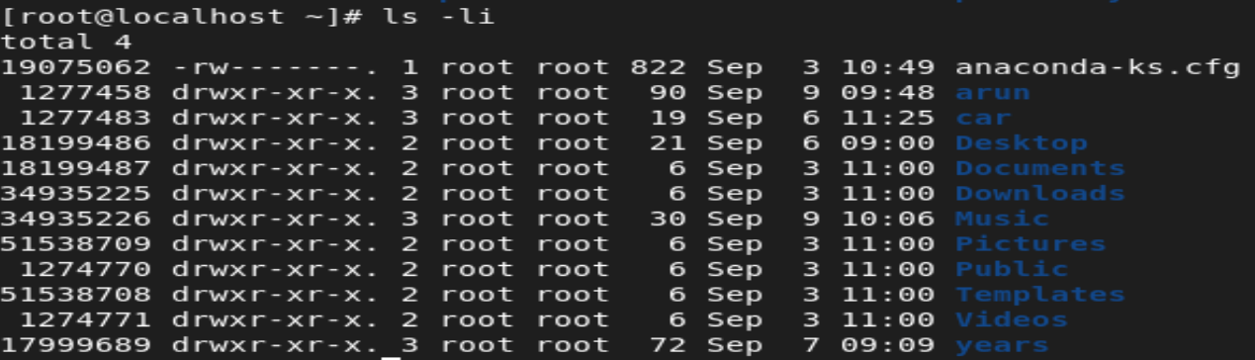

What is Stat Command?

* The stat command in Linux is a powerful tool that provides detailed information about files and file systems.

